

**COMSATS UNIVERSITY ISLAMABAD , ATTOCK CAMPUS**

**JAVASCRIPT SHOPPING CART SYSTEM**

**SUBMITTED BY : IRAM SAJJAD**

**SP22-BSE-023**

**SUBMITTED TO: SIR KAMRAN**

**ASSIGNMENT NO : 01**

**DATE : 26-09-2024**

**Introduction:**

Implement a shopping cart in JavaScript using ES6 arrow functions, array methods (map, filter, reduce), and object manipulation. The cart is capable of adding, removing, updating items, calculating the total cost, and applying discounts using arrow functions.

**Code Explanation:**

1. **Add Items to Cart:**  
   This function allows us to add products to the cart. It accepts parameters like product ID, product name, quantity, and price, and adds the product to an array representing the cart.

**OUTPUT OF CODE:**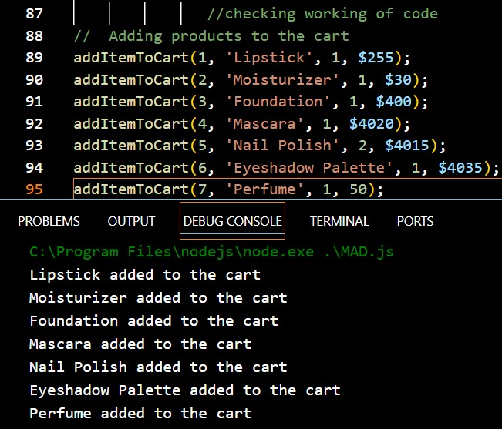

1. **Remove Item from Cart:**  
   This function removes an item based on the product ID. It uses array methods like findIndex and splice to remove the product.

**OUTPUT OF CODE:**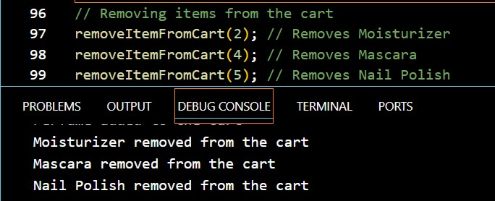

1. **Update Item Quantity:**  
   This function updates the quantity of a specific product by searching for its product ID and using map to modify the quantity.

**OUTPUT OF CODE:**

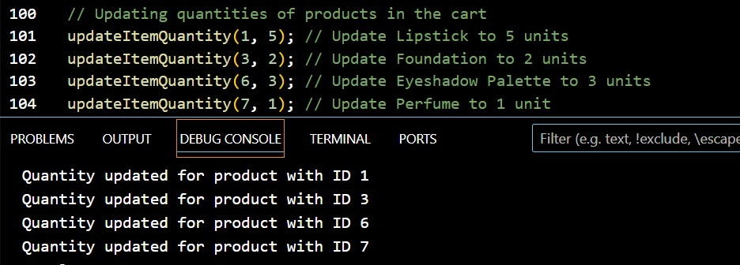

1. **Calculate Total Cost:**  
   This function uses the reduce method to sum up the total cost of all products, considering their quantity.
2. **Display Cart Summary:**  
   This function lists all the items in the cart, showing the product name, quantity, and total price.
3. **Apply Discount:**  
   An optional feature that applies a discount code to the total price.

**OUTPUT OF CODE:**

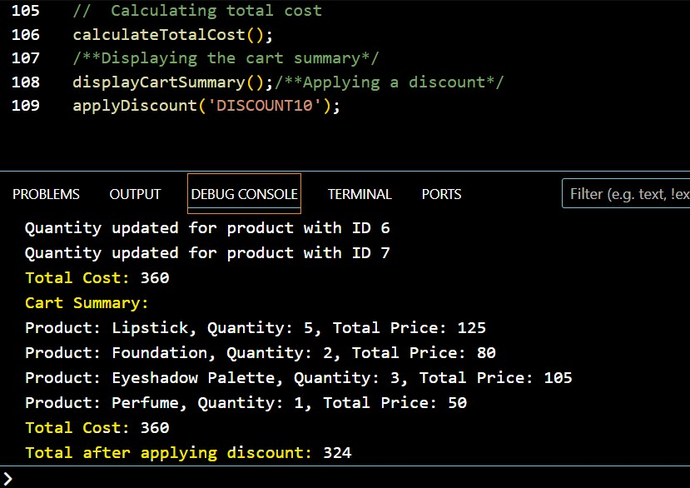

**Conclusion:**

This assignment taught me how to effectively handle a shopping cart using JavaScript functions such as map, filter, and reduce. I also got hands-on experience with arrow functions and applying discounts. One of the challenges I encountered was updating the cart and making sure the total price was calculated accurately, which really helped me enhance my debugging skills.